CIVICS

Lesson 8 and 9

1. Write characteristics of business persons?
Most businesspersons manage their own shops or business. They are not employed by anyone. But, they do employ a number of other workers as supervisors and helpers.

2. What are the drawbacks of casual jobs?
There is no job security or protection in casual job. If workers complain about their pay or working conditions they are asked to leave. They are paid less and expected to work for very long hours.

3.How do people earn their livelihood in the urban areas?
People of urban areas are engaged in different activities. Some are rickshaw pullers, some are vendors, some are business persons, some are shopkeepers, some works in call centres, some works in office etc.

4. Discuss the problems faced by the vendors.
Their shops are usually temporary structures. They can be asked to dismantle their shops at any time by the police. They have no security. There are certain parts of the city where these hawkers are not allowed to enter.

5.List some of the activities that poor families in rural areas often do for the household apart from farming.
Poor families in rural areas often spend a lot of time every day collecting firewood, getting water and grazing their cattle.
6. Under what circumstance farmers are unable to pay back their loans?
Crop failure due to bad quality of seeds, pests attack and delay in monsoon bring tough time for the farmers. Due to this farmers sometimes are unable to pay back their loans.

7. What are the reasons of crop failure?
The major reasons of crop failure are:
i. If the seeds are not of good quality.
ii. If pests attack the crop.
iii. If the monsoon does not bring enough rain.

8.What are the differences between those who sell on the street and those in the market?

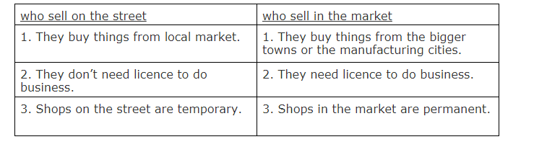

9.In what ways is a permanent and regular job different from a casual job? Discuss.
Permanent and regular job – In Permanent and regular job employee get a regular salary every month. Apart from salary, also gets other benefits such as savings for old age, holidays, medical facilities for their family etc.
Casual job - There is no job security or protection in casual job. If workers complain about their pay or working conditions they are asked to leave. They are paid less and expected to work for very long hours.

10. What are the benefits of a permanent job?

People in permanent jobs have following benefits:
i. They get regular salary every month.
ii. They can expect their job to continue for a long period of time.
iii. They get off on Sundays and national holidays. They also gets some days as annual leave.
iv. A part of their salary is kept in a fund with the government. They will earn interest on these savings. When they retire from their job they will get his money.

